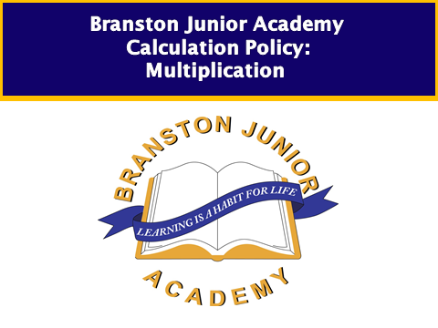

**Times tables progression**

Year 1 Count on or back in ones, twos, fives and tens and use this knowledge to derive the multiples of 2, 5 and 10 to the tenth multiple;

Recall the doubles of all numbers to at least 10

Year 2 Derive and recall multiplication facts for the 2, 5 and 10 times-tables and the related division facts; recognise multiples of 2, 5 and 10;

Derive and recall doubles of all numbers to 20, and the corresponding halves

Year 3 Derive and recall multiplication facts for the 2, 3, 4, 5, 6 and 10 times-tables and the corresponding division facts;

Recognise multiples of 2, 5 or 10 up to 1000

Year 4 Derive and recall multiplication facts up to 10 multiplied by10, the corresponding division facts and multiples of numbers to 10 up to the tenth multiple

Calculate doubles of multiples of 10 and 100 and derive the corresponding halves

Year 5 Recall quickly multiplication facts up to 10 multiplied by10 and use them to multiply pairs of multiples of 10 and 100;

Derive quickly corresponding division facts

Year 6 Use knowledge of place value and multiplication facts to 10 multiplied by10 to derive related multiplication and division facts involving decimals (e.g. 0.8 multiplied by7, 4.8 divided by6)

**Children working at below KS1 and entering year 1**

Related objectives: Solve practical problems that involve combining groups of 2, 5 or 10, or sharing into equal groups

* Children will experience equal groups of objects and will count in 2s, 5s and 10s and begin to count in 5s. They will work on practical problem solving activities involving equal sets or groups, e.g. Count five hops of 2 along this number track. What number will you reach? (Children will begin to move from using number tracks to number lines as appropriate through year 1 and 2)

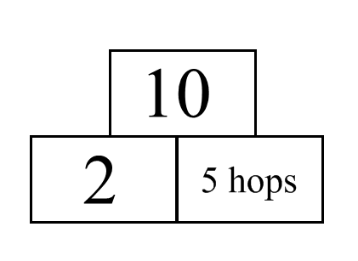

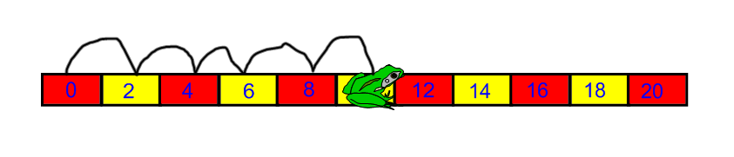

How many fingers are there altogether on six hands?

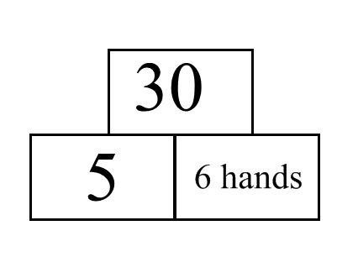

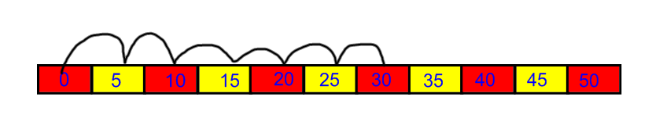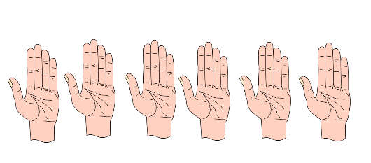

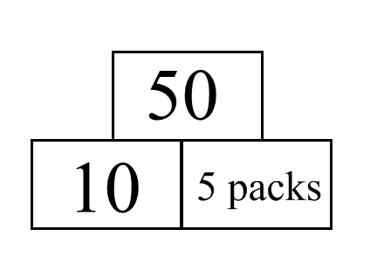There are 10 crayons in each box.

5 boxes of 10 crayons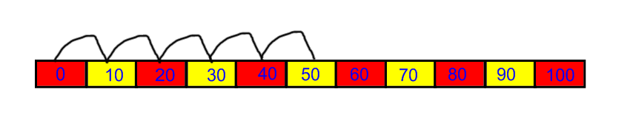How many crayons are there altogether?

**Children working at year 1 developing and secure**

Children will develop their understanding of multiplication and use jottings to support calculation:

* **Repeated addition**

Show me on a number line how you could do:

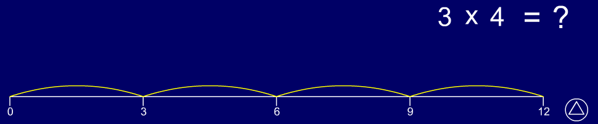

3 multiplied by4, how would 4 x 3 be different?

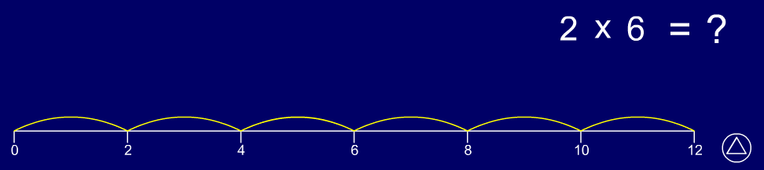

2 multiplied by6, how would 6 x 2 be different?

4 plus4 plus4 plus4 plus4 equals20  
Write this addition fact as a multiplication fact.

* **Commutativity**

Children should know that 3 x 5 has the same answer as 5 x 3 but describes a different situation. This can also be shown on the number line.

5

5

5

0 1 2 3 4 5 6 7 8 9 10 11 12 13 14 15

3

3

3

3

3

* **Arrays**

Children should be able to model a multiplication calculation using an array. This knowledge will support with the development of the grid method and makes links to division.

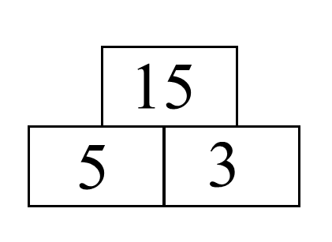

5 x 3 = 15

3 x 5 = 15

5 x 3 = 15

3 x 5 = 15

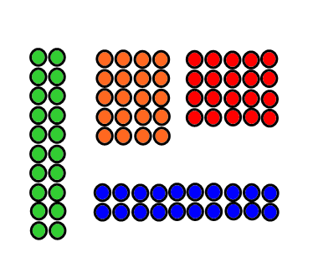

Here are 20 counters. How could you arrange them in equal rows? How could you use a number sentence to show your arrangement?

Link the above activity to missing box questions like the ones below.

What could the missing numbers be?

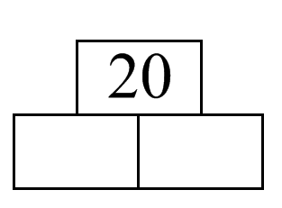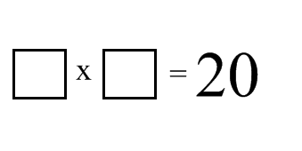

**Children working at year 2 and entering year 3**

Children will continue to use:

* **Repeated addition**

Children review **multiplication as repeated addition** and **division as repeated subtraction** by counting hops on a number line. For example, they find 6 fours by making 6 hops of 4.

A number line with 0, 4, 8, 12, 16, 20, 24 showing counting on in fours

Children **understand the relationship between multiplication and division** . For example, they state two multiplication sentences and two division sentences that relate to a particular array, for example:

A two column by five row grid

5multiplied by2equals10, 2multiplied by5equals10  
10divided by2equals5, 10divided by5equals2

They use the image of an array to explain why, for example, 2multiplied by5 gives the same answer as 5multiplied by2. They also use the image to show how many fives make 10 and how many twos make 10.

Children should use number lines or bead bars to support their understanding.

How many sides do six triangles have?

6

6

6

6

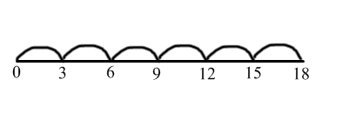

0 6 12 18 24

6

6

6

6

**Scaling**

e.g. Find a ribbon that is 4 times as long as the blue ribbon

5 cm 20 cm

Use facts from the first number grid (Number grid ITP) to derive facts on the second.

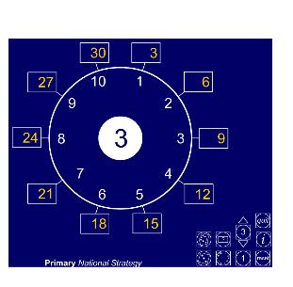 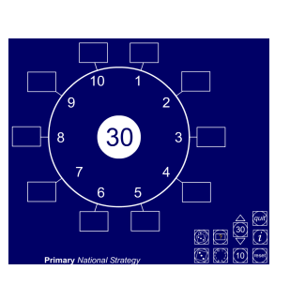

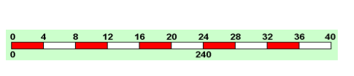

Use the counting stick to find how many 4s make 24.

Answer questions such as: 40 x 6, 4 x 60 by scaling up the product by a factor of 10.

* **Using symbols to stand for unknown numbers to complete equations using inverse operations**

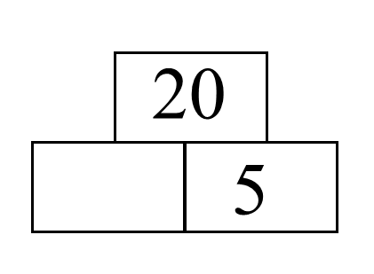 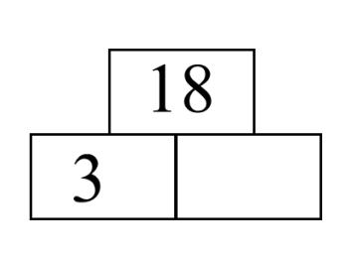 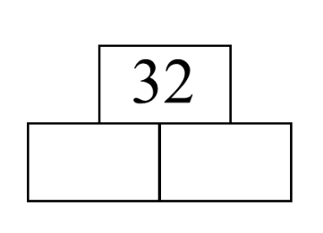

□ x 5 = 20 3 x △ = 18 □ x 🞅 = 32

* **Partitioning**

Children use partitioning to encourage them to us knowledge of 2, 5 and 10 times tables to work out multiples of 7, e.g. partition 7 into 5 and 2 to calculate 7 x 3, i.e.

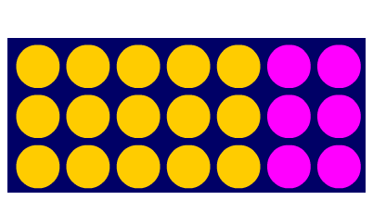

2 x 3

5 x 3

7 x 3

5 x 3 + 2 x 3

15 + 6

21

Children use partitioning to **multiply two-digit numbers by one-digit numbers**. For example, they work out 13 multiplied by3 by finding 10 multiplied by3 and adding 3 multiplied by3. They record their working using informal methods:

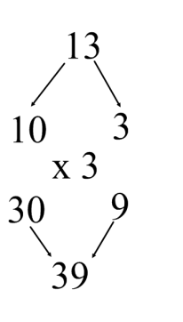 10 10 10

13 x 3 = (13) + (13) + (13) or

3 3 3

= 30 + 9

= 39

* Begin to use the grid method to represent larger arrays

3



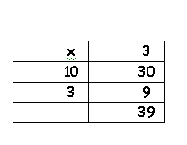

30

10

**Children working at developing and securing year 3**

Children will continue to use arrays where appropriate leading into the grid method of multiplication, as described above.

**Grid method**

**TU x U**

They refine their written methods for multiplying and dividing TU by U, including remainders.

38 multiplied by7 equals(30 multiplied by7) plus(8 multiplied by7) equals210 plus 56 equals266

|  |  |  |
| --- | --- | --- |
|  |  | Move between the steps using arrow cards to demonstrate the movement from the vertical layout of 30 + 8 to the horizontal layout. Children should be confident at adding two 2-digit numbers vertically before moving to the advanced stage |
| x | 7 |
| 30 | 210 |
| 8 | 56 |
|  | 266 |

Exploit the links to division, e.g.

|  |  |  |
| --- | --- | --- |
|  |  |  |
| 4 | 160 + 36 |

**Children working at year 4**

Related objectives: Extend mental-methods for whole-number calculations, for example to multiply a two-digit by a one-digit number (e.g. 12 multiplied by9), to multiply by 25 (e.g. 16 multiplied by25);

Use understanding of place value to multiply and divide whole numbers and decimals by 10, 100 or 1000

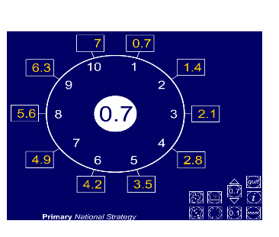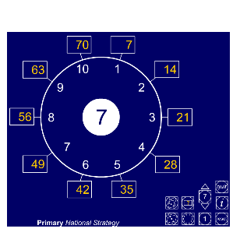

Use facts from the first number grid (Number grid ITP) to derive facts on the second by scaling down by a factor of 10.

Refine and use efficient written methods to multiply and divide HTU multiplied byU, TU multiplied byTU, U.t multiplied byU and HTU divided byU

**Grid method**

Children **develop and refine written methods for multiplication**. They move from expanded layouts (such as the grid method) towards a compact layout for HTU multiplied byU and TU multiplied byTU calculations. They suggest what they expect the approximate answer to be before starting a calculation and use this to check that their answer sounds sensible. For example, 56 multiplied by27 is approximately 60 multiplied by30 equals1800.

**HTU x U**

(Short multiplication – multiplication by a single digit)

346 x 9

|  |  |  |  |  |  |
| --- | --- | --- | --- | --- | --- |
|  |  |  | 300 40 6 |  | 346 |
| x | 9 |  | x 9 |  | x9 |
| 300 | 2700 |  | 2700 |  | 2700 |
| 40 | 360 |  | 360 |  | 360 |
| 6 | 54 |  | 54 |  | 54 |
|  | 3114 |  | 3114 |  | 3114 |

**TU x TU**

**56 x 27**

|  |  |  |  |  |  |  |  |  |  |  |
| --- | --- | --- | --- | --- | --- | --- | --- | --- | --- | --- |
|  |  | | |  | |  |  | 50 6 |  | 56 |
| x | | 20 | 7 | |  | |  | x 20 7 |  | x27 |
| 50 | | 1000 | 350 | | 1350 | |  | 1000 |  | 1120 |
| 6 | | 120 | 42 | | 162 | |  | 120 |  | 392 |
|  | | 1120 | 392 | | 1512 | |  | 350 |  | 1512 |
|  | |  |  | |  | |  | 42  1512 |  |  |

* **use and discuss mental strategies** **for special cases of harder types of calculations, for example to work out**

|  |  |
| --- | --- |
| The written steps below illustrate the process children might mentally go through, and does not necessarily need to be recorded each time a mental calculation takes place. | |
| * + even number x multiple of 5,   + e.g. 35 x 14   35 x (2 x 7)  (35 x 2) x 7  70 x 7  Ans: 490 | -near 10  12 x 19  (12 x 20) -12  120-12  Ans: 108 |
| * multiplying by 25 (or 50) e.g. 24 x 25   24 x 100 ÷2 ÷2  2400 ÷2 ÷2  1200 ÷2  Ans: 600 | * power of 2, e.g. 17 x 32   17 x2 =34  17 x4 =68  17 x8 =136  17 x16 =272  17 x32 =544 |

*Using similar methods, more able children will be able to multiply decimals with one decimal place by a single digit number, approximating first. They should know that the decimal points line up under each other.*

**Children working at year 5**

Written methods described above refined to efficient written methods and extended to HTUxTU and decimals.

**HTU x TU**

(Long multiplication – multiplication by more than a single digit)

372 x 24

Children will approximate first

372 x 24 is approximately 400 x 25 = 10 000

**56 x 27**

|  |  |  |  |  |  |  |  |  |  |  |
| --- | --- | --- | --- | --- | --- | --- | --- | --- | --- | --- |
|  |  | | |  | |  | 300 70 2 | |  | 372 |
| x | | 20 | 4 | |  | |  | x 20 4 |  | x24 |
| 300 | | 6000 | 1200 | | 7200 | |  | 7440 |  | 7440 |
| 70 | | 1400 | 280 | | 1680 | |  | 1200 |  | 1488 |
| 2 | | 40 | 8 | | 48 | |  | 280 |  | 8928 |
|  | |  |  | | 8928 | |  | 8  8928 |  |  |

**mental strategies**

|  |  |
| --- | --- |
| The written steps below illustrate the process children might mentally go through, and does not necessarily need to be recorded each time a mental calculation takes place. | |
| * + even number x multiple of 5,   + e.g. 3.5 x 14   3.5 x (2 x 7)  (3.5 x 2) x 7  7 x 7  Ans: 49 | -near 10  12 x £1.99  (12 x £2.00) –12p  £24.00-12p  Ans: £23.88 |
| * multiplying by 25 (or 50) e.g. 24 x 2.5   24 x 10 ÷2 ÷2  240 ÷2 ÷2  120 ÷2  Ans: 60 | * power of 2, e.g. 1.7 x 32   1.7 x2 =3.4  1.7 x4 =6.8  1.7 x8 =13.6  1.7 x16 =27.2  1.7 x32 =54.4 |

*Using similar methods, more able children will be able to multiply decimals with up to two decimal places by a single digit number and then two digit numbers, approximating first. They should know that the decimal points line up under each other.*

**Children working at year 6**

Will use column multiplication including when working with decimals and mixed place value. Focusing on estimation mentally to check answers. Key focuses on improving speed of calculations.