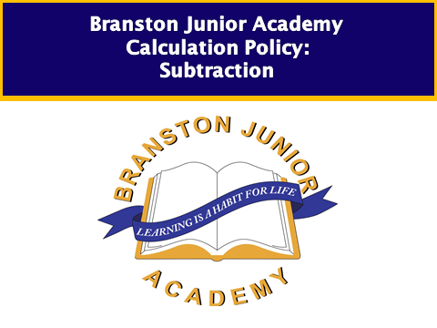

**Children below KS1 and entering year 1**

Children will use concrete equipment to represent written subtraction and then take away objects to calculate the answer.

*Children interpret subtraction as ‘taking away’. They represent ‘taking away’ using objects and with number sentences, recognising that the number of objects remaining is the answer in a calculation such as 15 – 11 = 5. They begin to rely less on manipulating practical resources and use strategies such as counting back on a number line or software that provides images and diagrams.*

*15 ducks are on the pond. 11 of them go away. How many are left?*

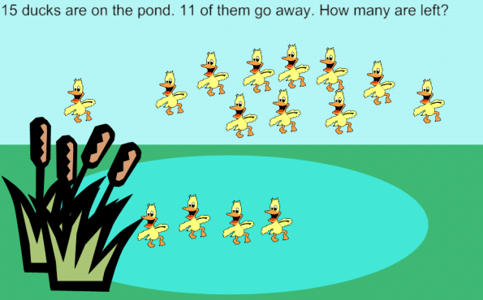

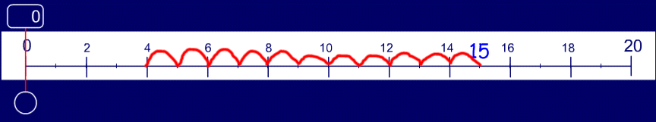

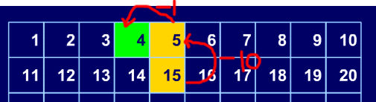

**Finding the difference**

*Children build on their understanding of subtraction to interpret 14 – 9 as finding the difference between 14 and 9 or: ‘How many more must I add to 9 to get 14?’ They use a counting on strategy and record the process as steps on a number line.*

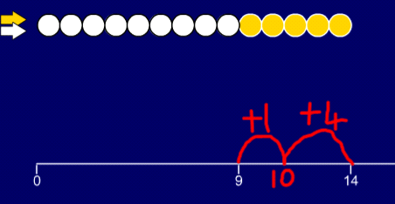

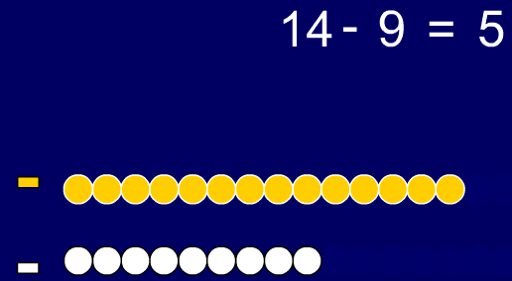

***Inverse relationship***

They construct sequences of calculations involving subtraction such as: 5 – 1 = 4, 6 – 2 = 4, 7 – 3 = 4, … They continue sequences such as: 12 – 0 = 12, 12 – 1 = 11, 12 – 2 = 10, … to build up patterns of calculations that highlight the underlying process of subtraction. They begin to recognise that subtraction and addition ‘undo each other’.

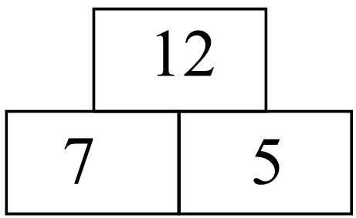

e.g. 7 + 5 = 12 and 12 – 7 = 5

*Children apply their knowledge to problems; for example, they work out how many biscuits are left on a plate of 13 biscuits if 4 are eaten. They solve problems such as finding the biggest and smallest possible differences between a pair of numbers from the set 8, 5, 12 and 6.*

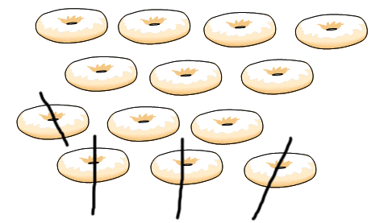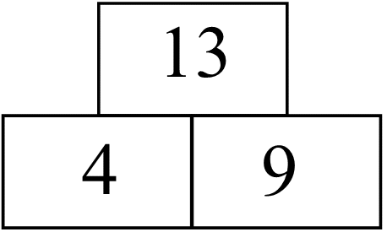

**Using +/- and = signs**

*Children record addition and subtraction number sentences using the operation signs + and –. They generate equivalent statements using the equals sign, for example:*

*7 = 6 + 1; 7 = 5 + 2 …etc*

*7 = 8 – 1; 7 = 9 – 2 …etc*

They recall the number that is 1 or 10 more or less than a given number and use this to support their calculations, for example to give answers to 12 + 1, 13 – 1 and 30 + 10 and 60 – 10.

Introducing two digit subtraction:

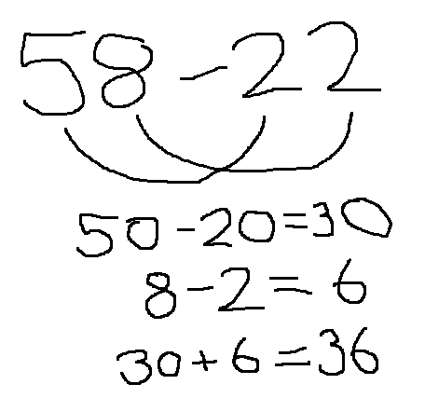

**Children working at developing and securing year 1**

*Children use the language of subtraction accurately. They read 16 – 4 = 12 as ‘sixteen minus four equals twelve’. They use their knowledge of number facts to add or subtract mentally a one digit number or a multiple of 10 to or from any two digit number. Children discuss and decide whether to: put the larger number first and count on or back; They use number lines, hundred squares and jottings to help them to carry out calculations.*

**Counting back**

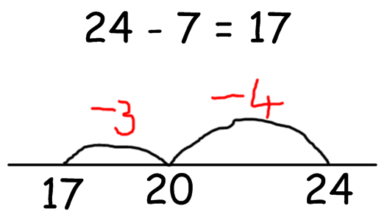

* counting back in tens and ones.

47 – 23 = 24

- 10

- 10

-1

-1

-1

24 25 26 27 37 47

* Then helping children to become more efficient by subtracting the units in one jump (by using the known fact 7 – 3 = 4).

47 – 23 = 24

24 27 37 47

-10

-10

-3

* Subtracting the tens in one jump and the units in one jump.

24 27 47

-20

-3

* Subtracting a multiple of 10 and adjusting

78 – 19 = 59

+1

-20

58 59 78

**Finding the difference e.g.** *Work out the difference between 46 and 18.*

Children should be encouraged to solve these types of calculation by representing both numbers initially on separate number lines and reinforcing the language of how many more or less, e.g.

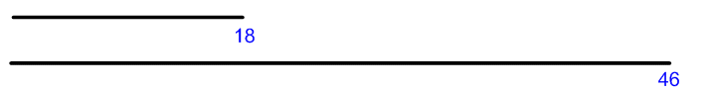

Through modelling and discussion, explore how this can represented as 46-18

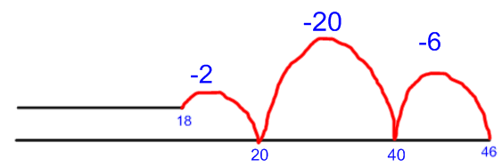

and that complementary addition (counting on) can be a useful checking strategy.

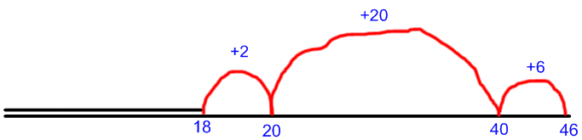

Children should be encouraged to decide which strategy to use depending on the numbers involved.

**Towards a standard written method (preparation for key stage 2)**

In preparation for understanding decomposition and division strategies taught in key stage 2, it is important that children gain experience of partitioning beyond simple tens and ones, e.g.

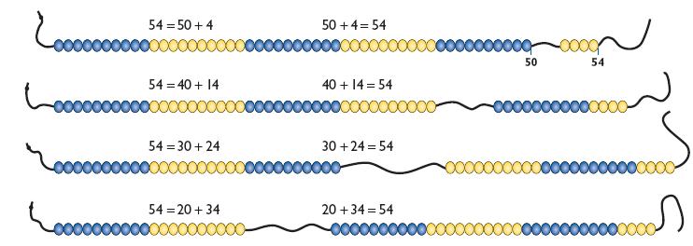

and

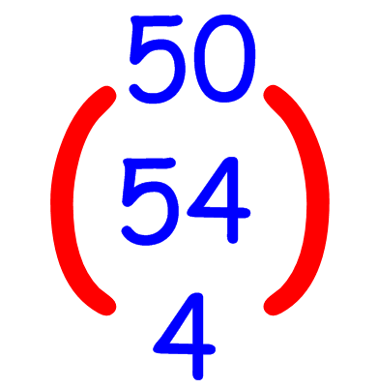 or 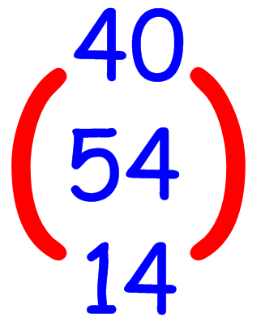 or 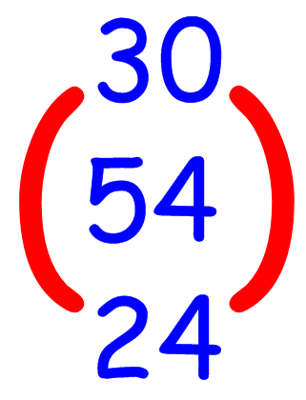…etc

**Inverse relationship**

Children know that addition and subtraction are inverse operations and can state the subtraction calculation corresponding to a given addition calculation and vice versa. They check their answers; for example, to confirm 24 – 7 = 17, they add 17 and 7.

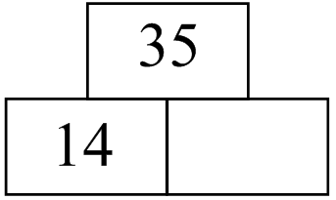

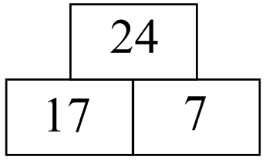

14plus square equals35. What is the missing number? How do you know? What subtraction could you do to find the answer?

**Children working at year 2**

*Children extend their mental calculation skills to add and subtract combinations of one-digit and two digit numbers such as: 14 – 8, 34 – 8, 34 – 18, 6 + 18, 6 + 58 and 16 + 58. In particular, they use their knowledge of addition and subtraction facts to 20 to add or subtract a one-digit number to or from any two-digit number, e.g. 63 + 8, 63 – 8.*

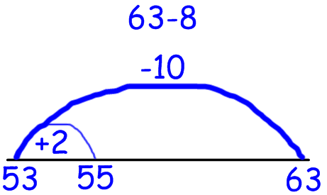

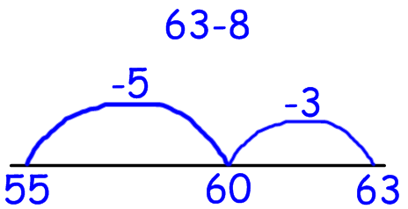

*Children continue to develop strategies for dealing with special cases, for example, finding 57 – 29 by subtracting 30 from 57 and adding 1 or by representing the calculation as 58 – 30. Children apply their understanding that the difference between two numbers will stay the same if both numbers are reduced or increased by the same amount. For example, finding the difference between 147 and 138 is the same as finding the difference between 47 and 38 or the difference between 49 and 40.*

*Children develop and use written methods to add and subtract two-digit and three-digit numbers. For calculations involving subtraction, children use a number line, subtracting the number that they are taking away in convenient and partitioned steps. The written method adopted should support the mental method used.*

*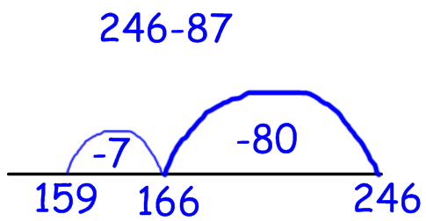 or*

**246 – 87** = 246 – 80 – 7

246

- 80

166

-7

159

**246 – 87** = 246 – 90 + 3

246

- 90

156

+3

159

*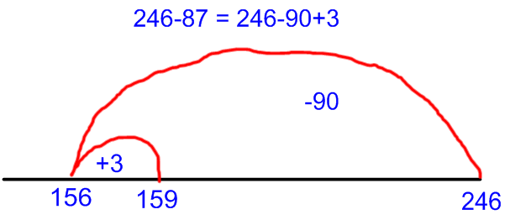 or*

*In other cases, they step up from the smaller number to the larger number. Children relate these number-line methods to expanded written methods of recording such as:*

**231 – 189** = 57

246

-189

+ 11 ⇒ 200

+ 46 ⇒ 246

57

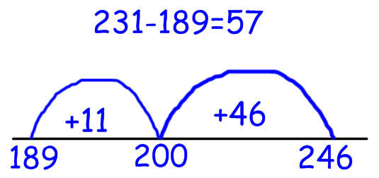

or

−

**Towards a standard written method**

During work on place value children need to continue to develop their understanding of partitioning beyond hundreds, tens and ones, e.g.

325 can be partitioned in a variety of ways, such as

325= 300 + 10 + 15 = 200 + 110 + 15… etc

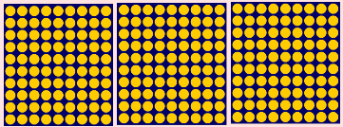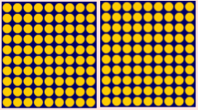**A useful visual image**:

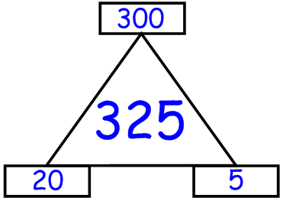

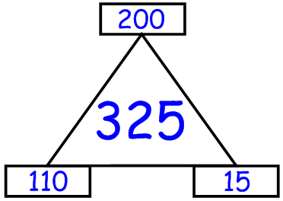

**

325 – 58 = 267

200 + 110 + 15

- 50 + 8

200 + 60 + 7

*Children begin to use their knowledge of place value and partitioning of three-digit numbers to develop their written methods for addition and subtraction of two- and three-digit numbers using expanded methods of recording:*

**Children working at year 3**

*Children subtract mentally pairs of two-digit whole numbers, e.g. 83 – 35. Some of them may need to make jottings to record the steps. They draw on their ability to partition numbers and count on or back, e.g.*

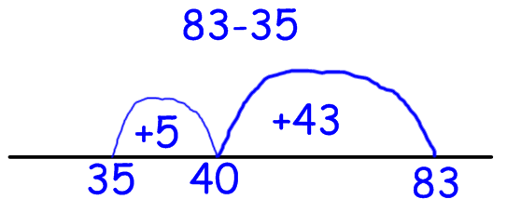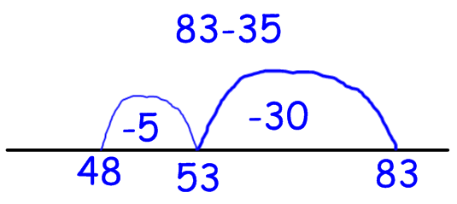

*or*

*They discuss their methods and look for methods that they can do most easily in their heads with little or no recording. Children use these mental methods to find the missing numbers in number sentences such as + 54 = 86, or 94 - □ = 52*

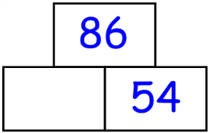 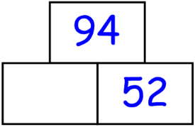

*Children apply their mental calculation skills to add and subtract multiples of 10 and 1000. For example, they work out what to add to 370 to make 1000, or 910 minus 740.*

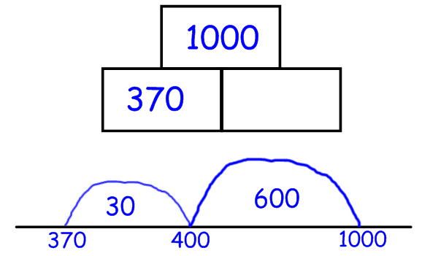 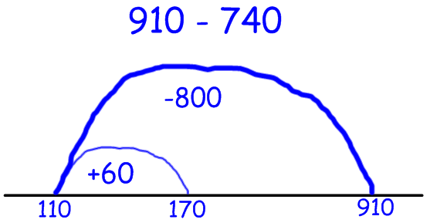

*They find the difference between two near numbers such as 7003 and 6988 by bridging across 7000 and adding 3 and 12 to get the answer 15. Where necessary, they continue to use jottings such as a number line to support mental calculations and to record methods that they explain to other children.*

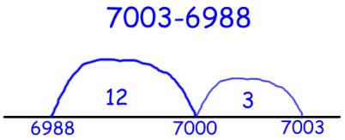

*Children recognise the need for conventions and rules when carrying out calculations involving more than one addition or subtraction. For example, they recognise that the answer to the calculation 9 – 5 – 3 is 1 and that the calculation is carried out from left to right – otherwise a different answer is obtained (if 5 – 3 is carried out first the answer is 7). Children test the effect that changing the order in which they carry out the steps in the calculation has on the answer. For example, they use a calculator to work out groups of calculations such as 24 + 29 – 47, 29 + 24 – 47, 24 – 47 + 29 and 29 – 47 + 24, and explain why the answers are the same. They recognise that addition can be done in any order and a calculation of the type A – B + C can be rewritten as A + C – B, and either A + C or C – B can be done first. They apply the rule to calculations such as 12 – 17 + 19 that they carry out mentally, rearranging this to 12 + 19 – 17 to avoid negative numbers.*

*Children build on their understanding of place value and partitioning to refine and use written methods of recording for the addition and subtraction of two- and three-digit numbers.* ***They always check first to see if they can do the calculations in their heads.*** *For example, they recognise that they can work out 50 + 76 and 60 – 28 in their heads, but that to answer 341 + 176 or 213 – 76 they need to record steps to help them. They begin to understand how the methods that they use relate to each other and, for particular calculations, why some methods are more efficient than others.*

*Introduce column subtraction to year 3:*

*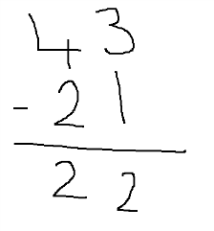initially where borrowing is not required and then 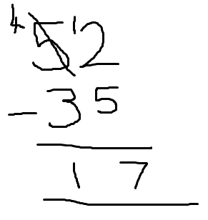looking at simple borrowing (possible modelling with dienes)*

**Children working at year 4**

Securing column subtraction method- introducing three digit

HA pupil may look at borrowing across the place value columns

**Children working at year 5**

*Children add and subtract mentally whole numbers and decimals with one place.*

*They use a secure, reliable method of written calculation for each operation. They recognise when one method is more efficient than another, for both whole and decimal numbers. They continue to check first if a mental method will work and then decide which method is most appropriate*

*Children should:*

* *be able to subtract numbers with different numbers of digits;*
* *be able to subtract with up to three digits and either one or two decimal places;*
* *Looking at borrowing across place values e.g*

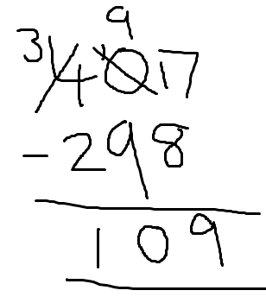

**Children working at year 6**

Key focuses on improving speed of calculations and using estimation to secure. Applying subtraction methods to problem solving and BODMAS.